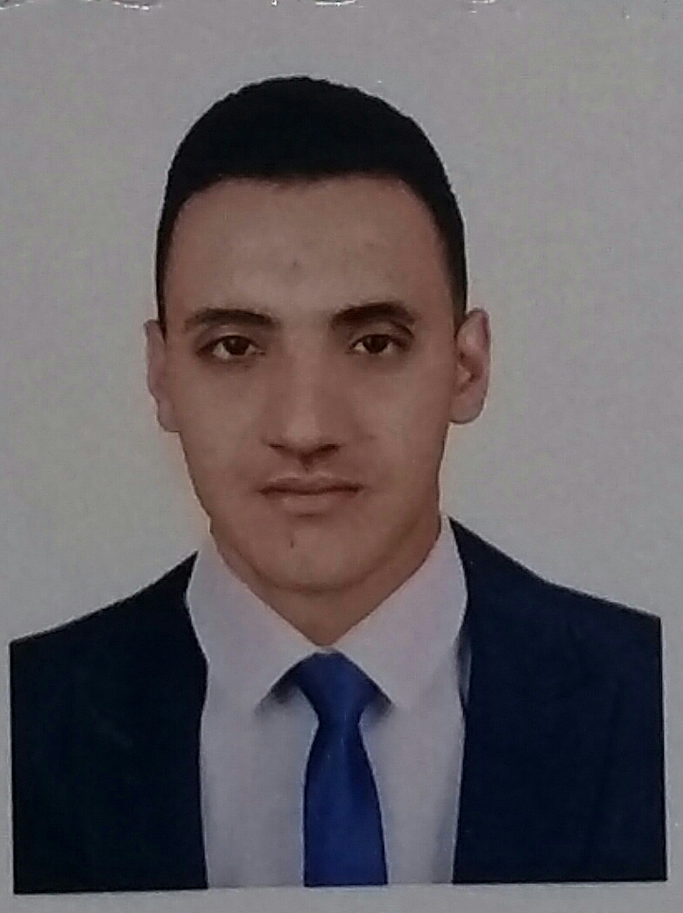
Name: Mustafa Ahmed Ali.
Address:Anbar_falluja
B.O.D: 26-1-1996
Telephone:07830014640
General Specialty: Civil Engineering
Specialty: Dams and water resources
Education: Bachelor's degree in hydraulics and water resources, Anbar University in 2017, graduation research entitled (Concrete Convas).
Experience:
1. Worked at Steel Structures Company in Fallujah city -Al Sadd street.
2. Worked as a testing engineer in the Al-Rasseen lab. for year.
Qualifications:
1. Mastering Microsoft Office programs especially Excel, Word and PowerPoint.
2. Proficiency in work on the ATOCAD program.
3. Holds a certificate working in surveying specially on the (Total Station).
4. Proficiency in English.

